Scrum Meetings
Sprint 1: The following is proof of scrum meetings.
09/04/25
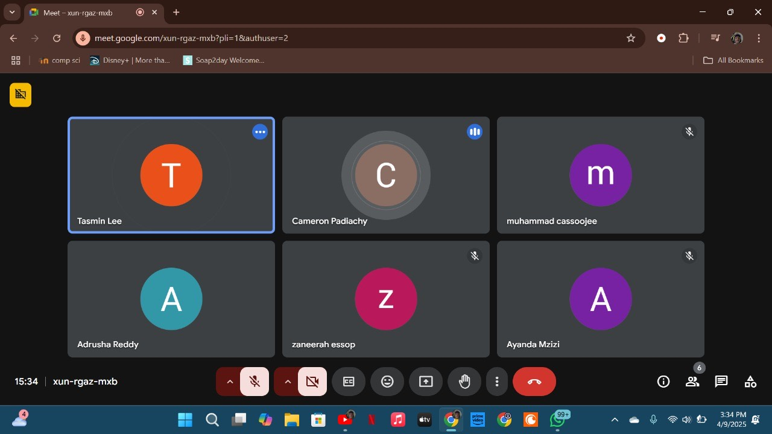
Daily Stand-Up Summary 1:
This was our first Daily Stand-Up meeting. In this meeting we planned out how we were going to go about doing tasks and assigning roles. Our main focuses were on setting up a GitHub repository as well as setting up Notion to create a sprint backlog. It was decided that Bradley, Cameron and Zaneerah would focus on backend aspects, while Adrusha, Muhammad and Tasmin were going to focus on frontend aspects. Zaneerah agreed to collaborate on frontend aspects as well. The blockers we encountered were installing and setting up Notion as this was our first time using this platform. Cameron also created the GitHub repository, and the rest of the group members joined it.

12/04/25
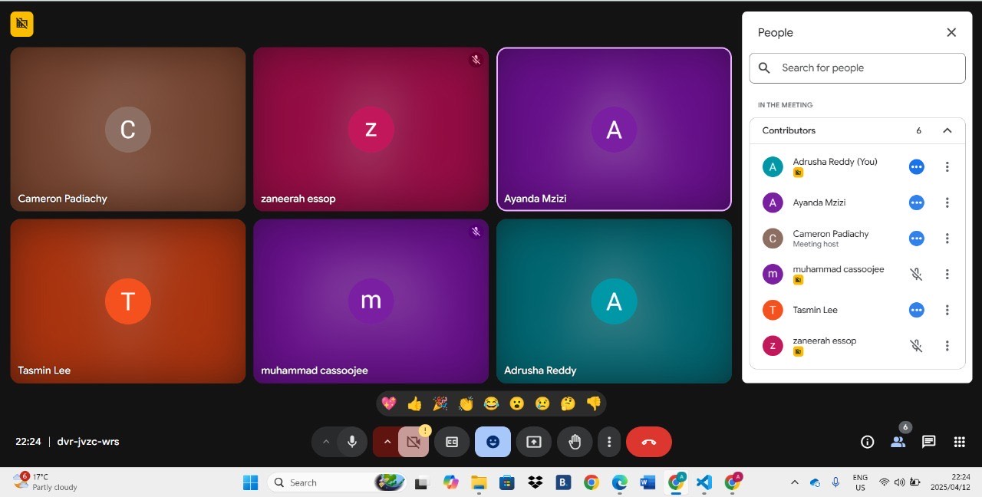
Daily Stand-Up Summary 2:
In this meeting we began a deeper discussion about the task at hand. We reviewed sprint requirements and began assigning tasks to members and creating a sprint backlog. Adrusha and Tasmin were assigned the html and css of the login page as well as doing the homepage. Muhammad and Tasmin were assigned the task of writing User Stories and User Acceptance Stories. Cameron and Bradley were assigned the task of setting up the Firebase. Zaneerah was assigned the task of setting up the Azure Database. Finally, Cameron and Zaneerah were assigned the task of setting up the Azure Instance. There were no actual blockers in this meeting, only a challenge. The challenge was identifying each members strengths and weaknesses when assigning tasks.

13/04/25
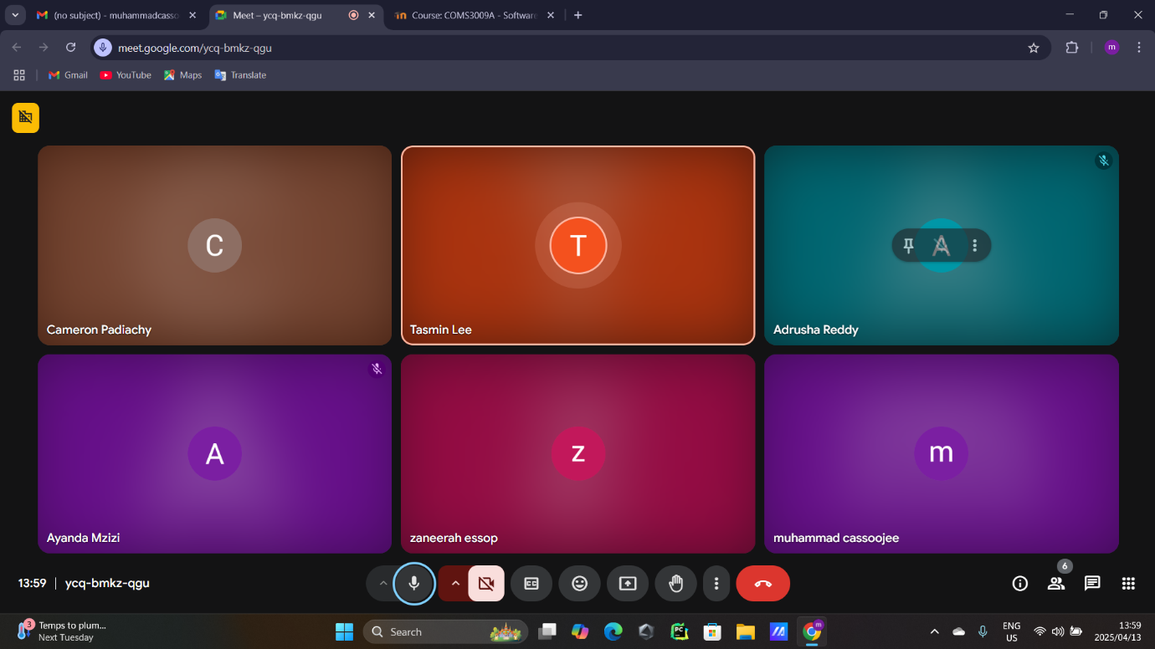
Daily Stand-Up Summary 3:
In this meeting the priorities of tasks were altered as they became more urgent as the deadline approached. The firebase setup, Azure Instance setup, Azure database setup, assigning roles within firebase, connecting the database to a server and deploying the front end to Azure were already completed by the following group members: Cameron, Bradley and Zaneerah. They did not encounter blockers and rather smoothly progressed with these tasks. Tasmin and Adrush began working on the login and homepages. The blocker they encountered was whether the login should allow people to create accounts that we store or only use a third party to allow logins. After further analysis of the task, only third-party logins were used (login with Google). Tasmin and Raees began with User Stories and User Acceptance stories without any blockers. Tasmin began creating users, 9 users with 3 roles each (User, Staff and Admin). Cameron also began writing tests for code coverage. Documentation work was assigned to Muhammad, which he did not begin as yet as it was of a lower priority compared to the other tasks.

14/04/25
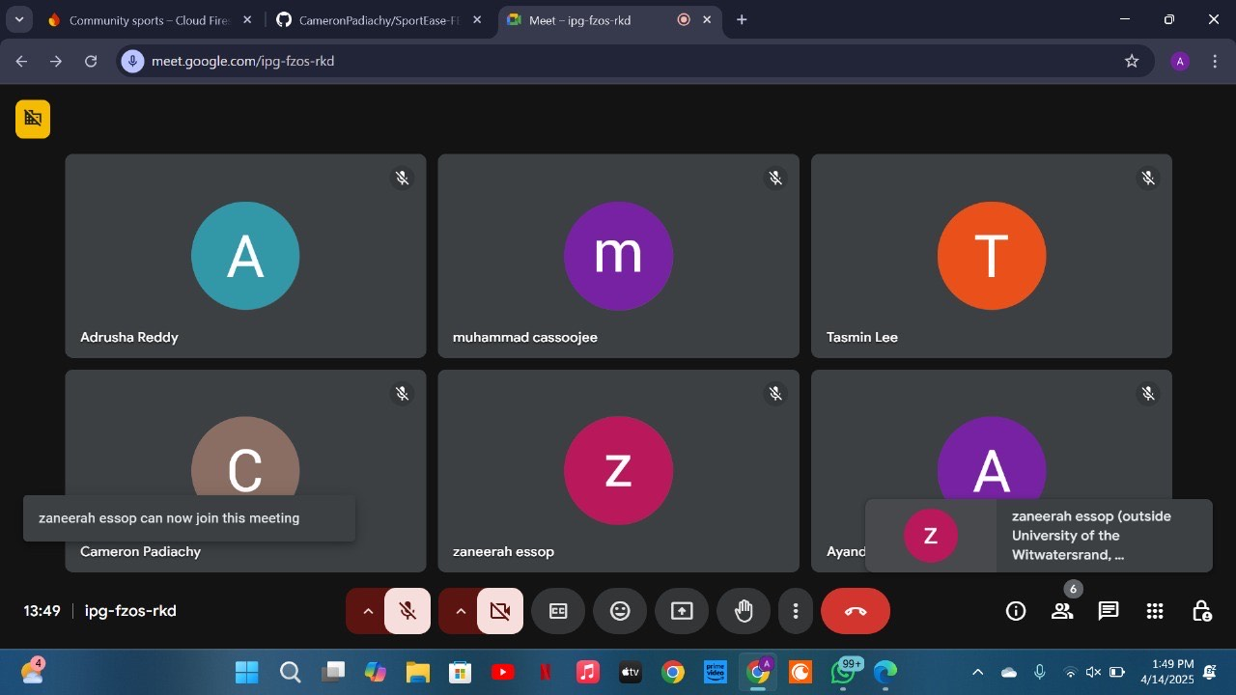
Daily Stand-Up Summary 4:
At this sprint the entire group were complete with their assigned tasks. The main blocker encountered, by Cameron, was writing jest tests. For tests to be written, code was needed to be tested. Hence it was done piece by piece as code was received. This can also be a tedious task as it was the first time writing code coverage. However, as time progressed it got better and the group could begin looking into sprint 2.

Sprint 1 Notion:
In these various scrum meetings, the project was analysed and broken down into smaller tasks. These tasks were then divided amongst the various group members, considering each members strengths and weaknesses. Various tasks were collaborated and done by two or three members. The group used notion to create a backlog and track progress on there. Tasks were created, assigned, tracked and prioritised. Here are screenshots of the group’s notion tasks:
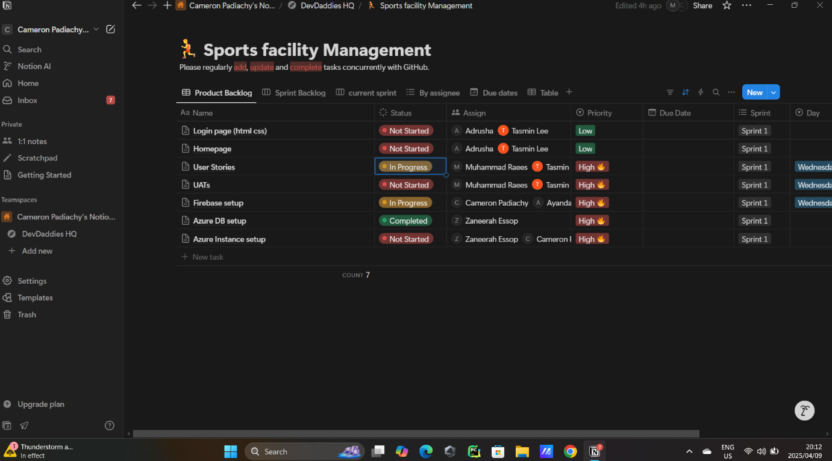

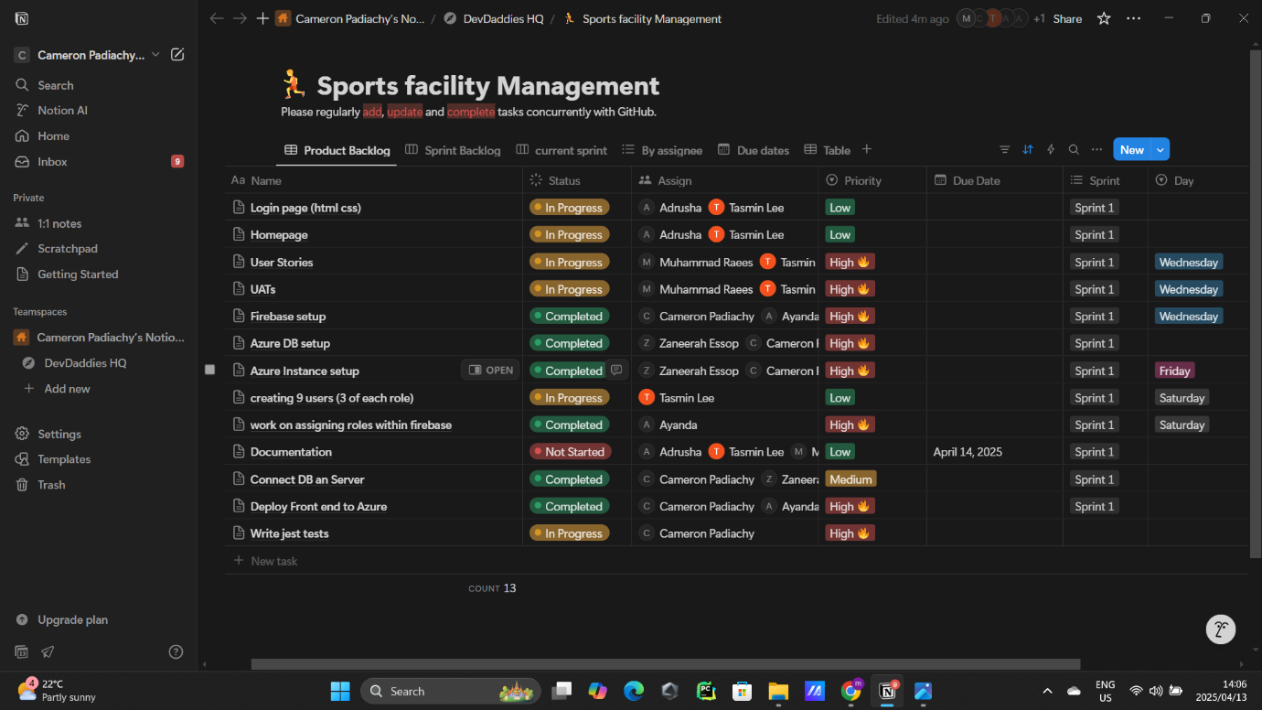

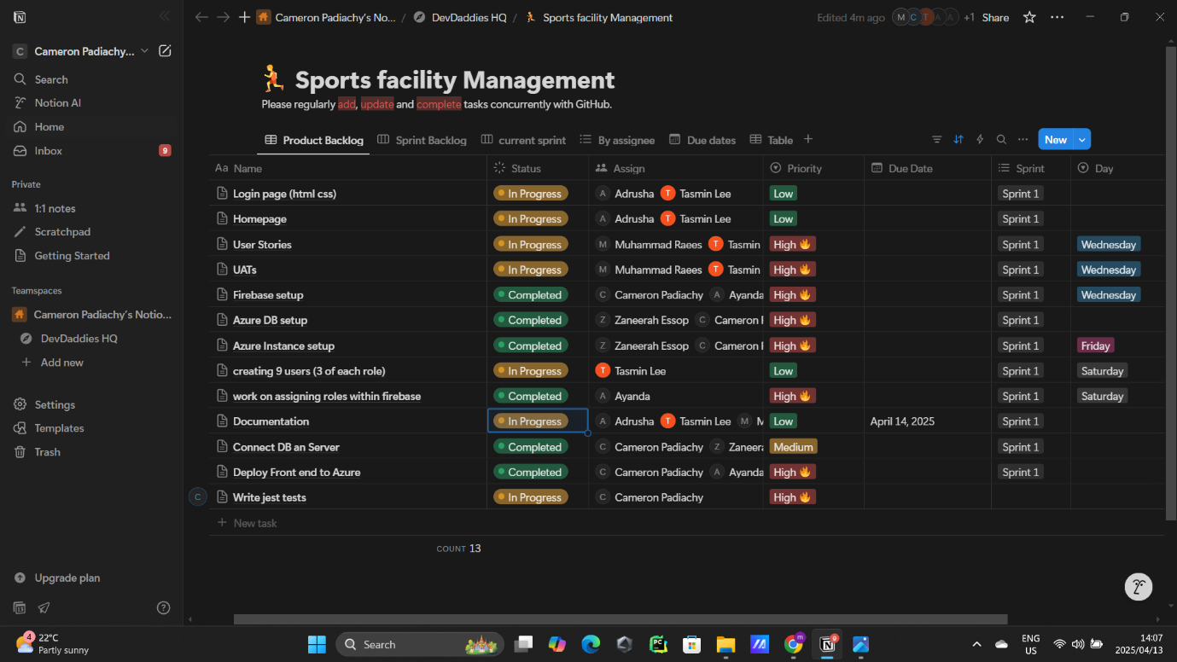
In these screenshots, we see how tasks are added and altered. Their priorities are changed as well as their status. As time passes, we see tasks going from “not started” to “in progress” to “completed”. This shows that the group, as a collective, are doing their assigned tasks and progress is being made.

Sprint 1 User stories:
- As a staff member, when logging in with valid credentials, I should be redirected to the staff homepage.
- As an admin, when logging in with valid credentials, I should be redirected to the admin homepage.
- As a resident, when logging in with valid credentials, I should be redirected to the resident homepage.
- As a user, when closing the login pop-up before submitting login details, an error message should be displayed on the screen, so that it can be told whether the login attempt was completed or not.

Sprint 1: Github
It is important in a group that we do not work standalone on a single individual’s laptop. Hence, public a Github repositorty with all members is created. In this repository various branches are created to maintain organisation and control. Now each member can include their work and make various commits as progress is made. The following are screenshots of our repository, where each member has made a commit:
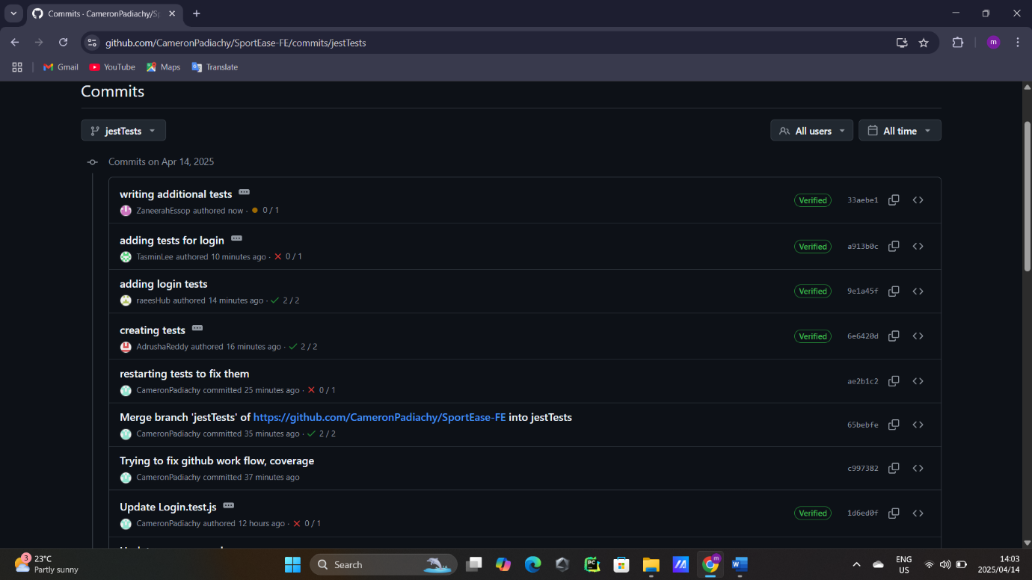
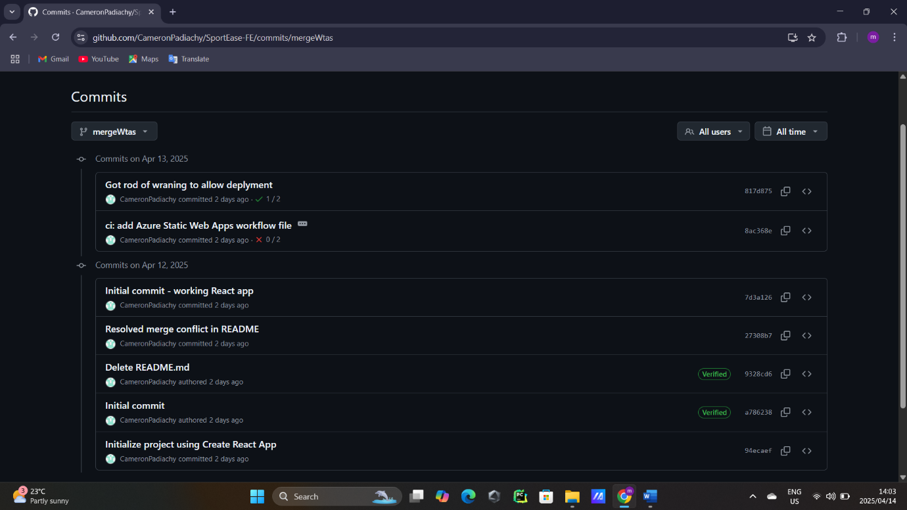
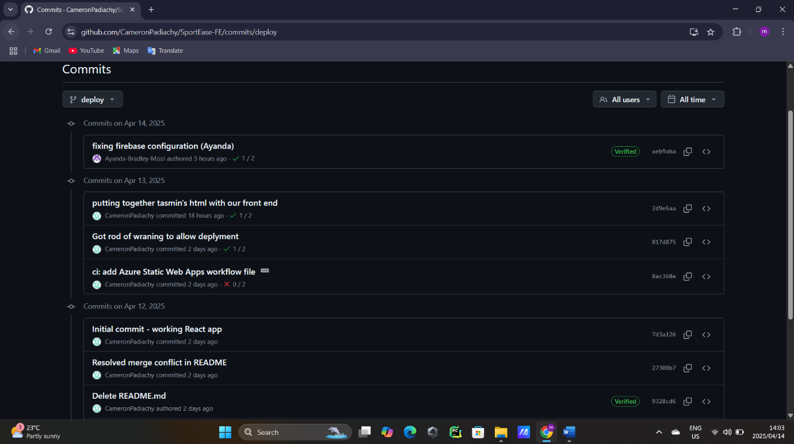
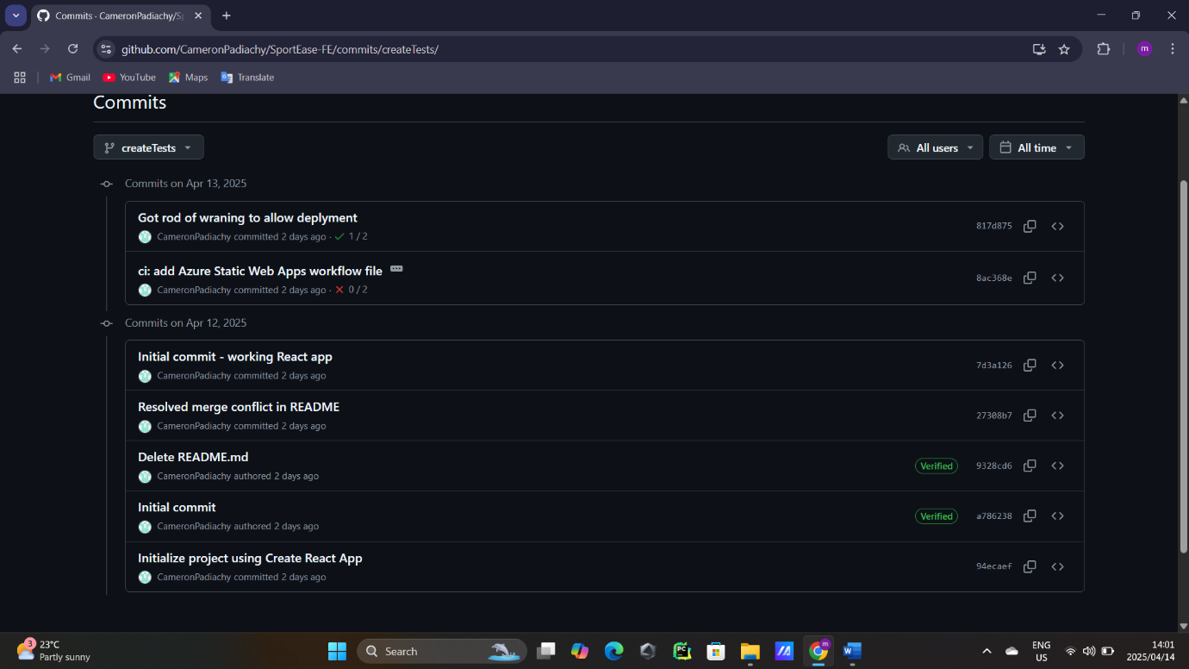

Sprint 1 User acceptance tests:
- Given that I am a staff user, and valid staff login credentials are entered, when logging in, then a redirection to the staff homepage should occur.
- Given that I am an admin user, and valid admin login credentials are entered, when logging in, then a redirection to the admin homepage should occur.
- Given that I am a resident user, and valid resident login credentials are entered, when logging in, then a redirection to the resident homepage should occur.
- Given that I am on the login screen, and the login pop-up before submitting my credentials are closed, when an attempt to proceed without logging in is made, then an error message should be displayed on the screen.

Accounts, logins and roles
- justinyamada67@gmail.com (resident)
DeadLock11
- dannyfine00@gmail.com (resident)*
Dannyfine#0123
- johnhawkins230195@gmail.com (staff)*
JH230195
- oliverbird46@gmail.com (staff)
$dproject46
- brunojupiter47@gmail.com (admin)*
$dproject47
- rachelgrey349@gmail.com (admin)
JellyBean67
- bernardarmand29@gmail.com (admin)
Jellycat60%
- dylanjaynun@gmail.com (resident)
bumblebee44$
- jenniefergreen773@gmail.com (staff)
yellowflower

